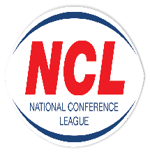NATIONAL CONFERENCE LEAGUE 2022

Minutes of the Discipline Hearing held on Monday 8 August
 |  |  |  |  |  |  |  | 8
NCL 89 | Club | Bradford Dudley Hill | 18 06 2022 |  | Discipline Charter  40 Points | Guilty  Fined £40
NCL 103 | Nic Caldwell (Coach) | York Acorn | 02 07 2022 | Personal | Foul Language To Match Official | Guilty  4 Match Touchline Ban Reduced To 2 Match Ban For Previous Good Record & Guilty Plea  £40 Fine | 11 August 2022 | Yes
NCL 109 | Adam Holland | Leigh East | 02 07 2022 | Personal | Lashing Out Reaction To Opponent | Guilty  4 Match Ban  Reduced To 2 Games For Previous Good Record & Guilty Plea  £40 Fine
NCL 110 | Dillan Thornton | Hunslet Warriors | 16 07 2022 | None | Head Butt  Light Contact | Guilty  5 Match Ban  £100 Fine | 11 08 2022 | No
NCL 112 | Adam Biscombe | Normanton | 16 07 2022 | Personal | Punching To Head | Guilty  5 Match Ban  £100 Fine | 11 08 2022 | Yes
NCL 116 | Chris Hough | Saddleworth Rangers | 16 07 2022 | Personal | Engaged In Unacceptable Language  & Behaviour | Guilty  9 Match Ban Reduced To 8 Games For Previous Good Record  £100 | 11 08 2022 | Yes
NCL 117 | Jake Starbuck | Bentley | 23 07 2022 | Personal | Light Contact  Head Butt | Not Guilty | NA | NA
NCL 119 | Finley Bruce | Dewsbury Moor | 23 07 2022 | Personal | Punching | Not Guilty | NA | NA
NCL 120 | James Delaney  (Coach) | Dewsbury Moor | 23 07 2022 | Personal | Foul Language | Guilty  2 Match Touchline Ban Reduced To 1 Match Touchline Ban Suspended Until 31 12 2022 | NA | Yes
NCL 121 | Charlie Barker | Normanton | 23 07 2022 | Personal | Careless Contact To Head | Guilty  1 Match Ban Reduced To Sending Off Sufficient For Previous Good Record | NA | Yes
NCL 124 | Max Jones | Milford | 23 07 2022 | Personal | Punching | Guilty  8 Match ban Reduced To 6 Games For Previous Good Record & Guilty Plea  £100 Fine | Immediately | Yes
NCL 125 | Callum Clark | Milford | 23 07 2022 | Personal | Punching | Guilty  8 Match ban Reduced To 6 Games For Previous Good Record & Guilty Plea  £100 Fine | Immediately | Yes
NCL 126 | Ryan Brown | Woolston | 23 07 2022 | Personal | Reckless Strikes with Arm | Guilty 2 Match Ban Reduced To 1 Game For Previous Good Record  £20 Fine | 11 08 2022 | Yes

The administration fee set aside for clubs wishing to contest the content of a match official’s report is £20, however this becomes £40 in the event of representation for two players or £60 should three players, from the same club, having been dismissed in a game wish to seek personal representation at the next discipline hearing.
All disciplinary fines imposed by the National Conference League must be remitted directly in full to the Administrator for receipt at the address below on or before
1st September 2022. The 28 day ruling given for payment applies from the original hearing date and not the date of any appeal decision.
Please Note – Notification of Suspensions/Games Served The League will not, in the run up to the 28 day expiry date window, issue reminders to clubs having failed within this period allowed to settle fines imposed. This template acts as the official notice issued by the National Conference League confirming the suspension or otherwise of players. Players against whom fines are imposed are NOT eligible for selection by their club.
Clubs must ensure that payments (Banker Cheques in favour of “NCL”) are secure as losses by post unless proven beyond all reasonable doubt cannot be classified as an excuse for non-payment by the final deadline date as issued in this communication.

Alternatively, clubs may, if they so wish and have a facility available to do so payments on-line directly to the NCL account. The NCL account number is: 29678277 Sort Code 606005 and name of account “National Conference League” When exploiting this option clubs must forward to me on the actual date of payment an email confirming that it has been made and the reason for the direct transaction. Any payment not received within 28 days from the date of imposition will mean the original fine being doubled accordingly. The NCL is not obliged to provide clubs with reminders warning them of a timescale for payment having elapsed without receipt
A Smith (NCL Administrator) Operations Dept, RFL, Cwm Ban Fawr, Llanfynydd, Carmathen, SA32 7UB.

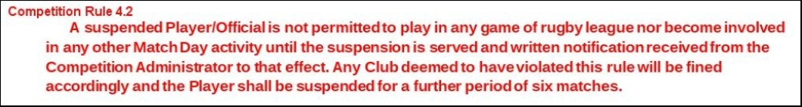

A Smith (NCL Administrator) Operations Dept, RFL, Cwm Ban Fawr, Llanfynydd, Carmathen, SA32 7UB.

