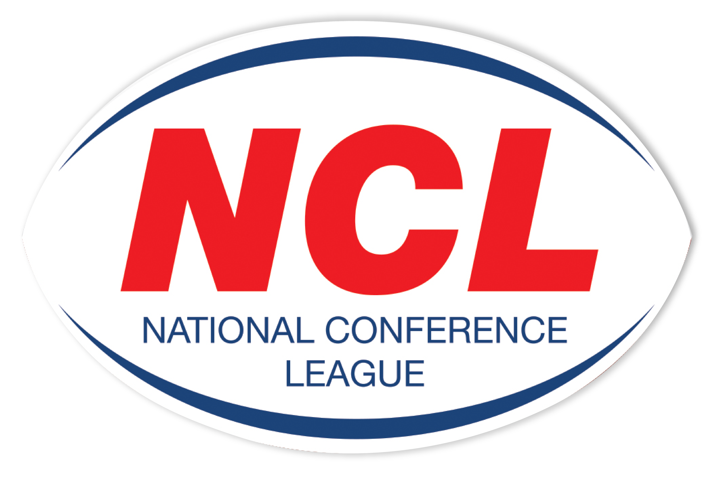NATIONAL CONFERENCE LEAGUE 2022

Minutes of the Discipline Hearing held on Wednesday 13 April 2022
 | Name | Club | Match Date | Present | Nature of Offence | Decision | Suspension Starts | Right of  Appeal
NCL 012 | Reece Hamlet | Rochdale Mayfield | 05 03 2022 | Personal | Punching With Open Hand To Head  Law 15.1 a | Guilty  2 Match Ban  Reduced To 1 Game Ban For Previous Good Record  £20 Fine | 16 04 22 | No
NCL 020 | Chris Piercy | Myton Warriors | 19 03 2022 | None | Head Butt  Full Contact  Law 15.1 a | Guilty  5 Match Ban Reduced to 4 Matches For Previous Good Record  £80 Fine | 16 04 22 | No
NCL 022 | Club | Featherstone Lions | 19 03 2022 | Called In | Not Fulfilling Fixture | Guilty  £500 Fine of which £200 is suspended to end of NCL Season | NA | No
NCL 023 | Robert Tyson-Wilson | West Hull | 26 03 2022 | Written | Reckless Elbow to The Head  Law 15.1 b | Guilty  3 Game Ban  £60 Fine | 16 04 22 | Yes
NCL 024 | Tony Burns | Kells | 26 03 2022 | Personal | Careless High Tackle  Law 15.1 b | Guilty  Sending Off Sufficient | NA | Yes
NCL 025 | Alfie Crawford | East Leeds | 26 03 2022 | Written | Kick To Body  Law 15.1 a | Guilty  4 Match Ban Reduced to 3 Games for Previous Good Record  £40 |Fine | 16 04 22 | Yes
NCL 026 | Dale Lowe | Waterhead | 26 03 2022 | Personal | Careless High Tackle  Law 15.1 b | Guilty  1 Match Ban Reduced to Sending Off Sufficient For Previous Good Record | 16 04 22 | Yes
NCL 028 | Antony Nicholls | Leigh East | 26 03 2022 | None | Punch To Head  Law 15.1 a | Guilty  4 Match Ban £80 Fine | 16 04 22 | No
NCL 029 | Jacob Crossland | Normanton | 26 03 2022 | Personal | Punching To Head  Law 15.1 a | Guilty  5 Match Ban Reduced To 4 Game Ban For Guilty Plea  £80 Fine | 16 04 22 | Yes
NCL 030 | Club | Normanton | 26 03 2022 | Called In | Unacceptable Behaviour & Language  Law 15.1 k | Not Guilty | NA | NA
NCL 031 | Brad Clarkson | Bradford Dudley Hill | 26 03 2022 | Called In | Spitting  Law 15.1 i | Not Guilty | NA | NA
NCL 037 | Club | Featherstone Lions | 02 04 2022 |  | Playing An Unregistered Player | No Case To Answer | NA | NA

The administration fee set aside for clubs wishing to contest the content of a match official’s report is £20, however this becomes £40 in the event of representation for two players or £60 should three players, from the same club, having been dismissed in a game wish to seek personal representation at the next discipline hearing.
All disciplinary fines imposed by the National Conference League must be remitted directly in full to the Administrator for receipt at the address below on or before
6th April 2022. The 28 day ruling given for payment applies from the original hearing date and not the date of any appeal decision.
Please Note – Notification of Suspensions/Games Served The League will not, in the run up to the 28 day expiry date window, issue reminders to clubs having failed within this period allowed to settle fines imposed. This template acts as the official notice issued by the National Conference League confirming the suspension or otherwise of players. Players against whom fines are imposed are NOT eligible for selection by their club.
Clubs must ensure that payments (Banker Cheques in favour of “NCL”) are secure as losses by post unless proven beyond all reasonable doubt cannot be classified as an excuse for non-payment by the final deadline date as issued in this communication.

Alternatively, clubs may, if they so wish and have a facility available to do so payments on-line directly to the NCL account. The NCL account number is: 29678277 Sort Code 606005 and name of account “National Conference League” When exploiting this option clubs must forward to me on the actual date of payment an email confirming that it has been made and the reason for the direct transaction. Any payment not received within 28 days from the date of imposition will mean the original fine being doubled accordingly. The NCL is not obliged to provide clubs with reminders warning them of a timescale for payment having elapsed without receipt
A Smith (NCL Administrator) Operations Dept, RFL, Cwm Ban Fawr, Llanfynydd, Carmathen, SA32 7UB.

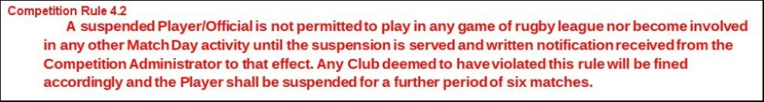

A Smith (NCL Administrator) Operations Dept, RFL, Cwm Ban Fawr, Llanfynydd, Carmathen, SA32 7UB.

