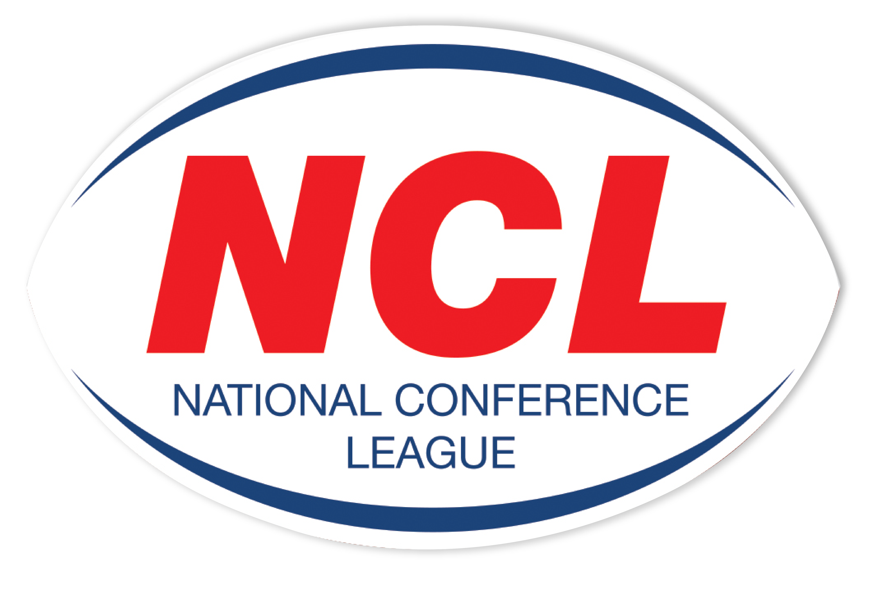NATIONAL CONFERENCE LEAGUE 2022

Minutes of the Discipline Hearing held on Wednesday 15 June 2022
 | Name | Club | Match Date | Present | Nature of Offence | Decision | Suspension Starts | Right of  Appeal
NCL 58 | Club | Beverley | 07 05 2022 | Called In | Failing To Fulfil Fixture | Guilty  Fined £500 of Which £200 Is Suspended to End Of 2023 Season | NA | No
NCL 59 | James Worthington | Wigan St Judes | 14 05 2022 | Written | Punching To Head  Law 15.1A | Guilty  4 Match Ban Reduced To 2 Games For Previous Good Record & Guilty Plea  £20 Fine | 18 June 22 | Yes
NCL 62 | Liam Brown | Hunslet Warriors | 21 05 2022 | Personal | Running In & Punching To Head  Law 15.1A  Other Contrary Behaviour After Being Dismissed  Law 15.1i | Guilty 6 Game Ban  £100 Fine | 18 June 22 | Yes
NCL 63 | Frank Chestney | Clock Face Miners | 21 05 2022 | None | Trip  Law 15.1a | Guilty  2 Match Ban Reduced To 1 Game For Previous Good Record  £20 Fine | 18 June 22 | No
NCL 64 | Jenson Hamilton | Waterhead | 21 05 2022 | Personal | Punching  Law 15.1A | Guilty 4 Game Ban Reduced To 2 Games For Previous Good Record & Guilty Plea  £40 | 18 June 22 | Yes
NCL 66 | Owen McCartney | Wath Brow Hornets | 28 05 2022 | Personal | Running In & Punching  Law 15.1 A | Guilty  5 Game Ban Reduced To 4 Games For Previous Good Record  £100 Fine | 18 June 22 | Yes
NCL 67 | Toby Currie | Egremont Rangers | 28 05 2022 | Personal | Running In & Punching  Law 15.1a | Guilty  5 Game Ban Reduced To 4 Games For Previous Good Record  £100 Fine | 18 June 22 | No
NCL 69 | Jarty Robinson | Millom | 04 06 2022 | Personal | Punching To Head  Law 15.1a | Guilty  4 Game Ban Reduced To 3 For Previous Good Record  £60 Fine | 18 June 22 | Yes
NCL 70 | Stephen Hodgson | Hensingham | 04 06 2022 | None | Punching To Head  Law 15.1a | Guilty  4 Game Ban Reduced To 3 For Previous Good Record  £60 Fine | 18 June 22 | No
NCL 82 | Declan Nicholson | Eastmoor | 11 06 2022 | Written | High Tackle To Head  Law 15.1 | Guilty  7 Match Ban Reduced to 6 Games For Guilty Plea  £100 Fine | Immediate | Yes
NCL 85 | Joshua Burland | Dewsbury Moor | 11 06 2022 | Written | Running In & Punching To Head  Law 15.1 | Guilty  8 Match Ban Reduced To 6 Games For Previous Record & Guilty Plea  £100 Fine | Immediate | Yes

The administration fee set aside for clubs wishing to contest the content of a match official’s report is £20, however this becomes £40 in the event of representation for two players or £60 should three players, from the same club, having been dismissed in a game wish to seek personal representation at the next discipline hearing.
All disciplinary fines imposed by the National Conference League must be remitted directly in full to the Administrator for receipt at the address below on or before
15 July 2022. The 28 day ruling given for payment applies from the original hearing date and not the date of any appeal decision.
Please Note – Notification of Suspensions/Games Served The League will not, in the run up to the 28 day expiry date window, issue reminders to clubs having failed within this period allowed to settle fines imposed. This template acts as the official notice issued by the National Conference League confirming the suspension or otherwise of players. Players against whom fines are imposed are NOT eligible for selection by their club.
Clubs must ensure that payments (Banker Cheques in favour of “NCL”) are secure as losses by post unless proven beyond all reasonable doubt cannot be classified as an excuse for non-payment by the final deadline date as issued in this communication.

Alternatively, clubs may, if they so wish and have a facility available to do so payments on-line directly to the NCL account. The NCL account number is: 29678277 Sort Code 606005 and name of account “National Conference League” When exploiting this option clubs must forward to me on the actual date of payment an email confirming that it has been made and the reason for the direct transaction. Any payment not received within 28 days from the date of imposition will mean the original fine being doubled accordingly. The NCL is not obliged to provide clubs with reminders warning them of a timescale for payment having elapsed without receipt
A Smith (NCL Administrator) Operations Dept, RFL, Cwm Ban Fawr, Llanfynydd, Carmathen, SA32 7UB.

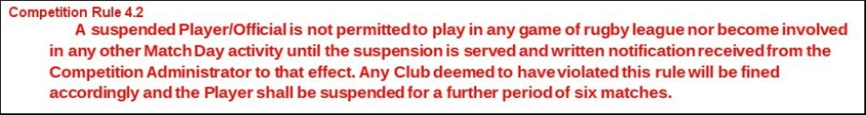

A Smith (NCL Administrator) Operations Dept, RFL, Cwm Ban Fawr, Llanfynydd, Carmathen, SA32 7UB.

