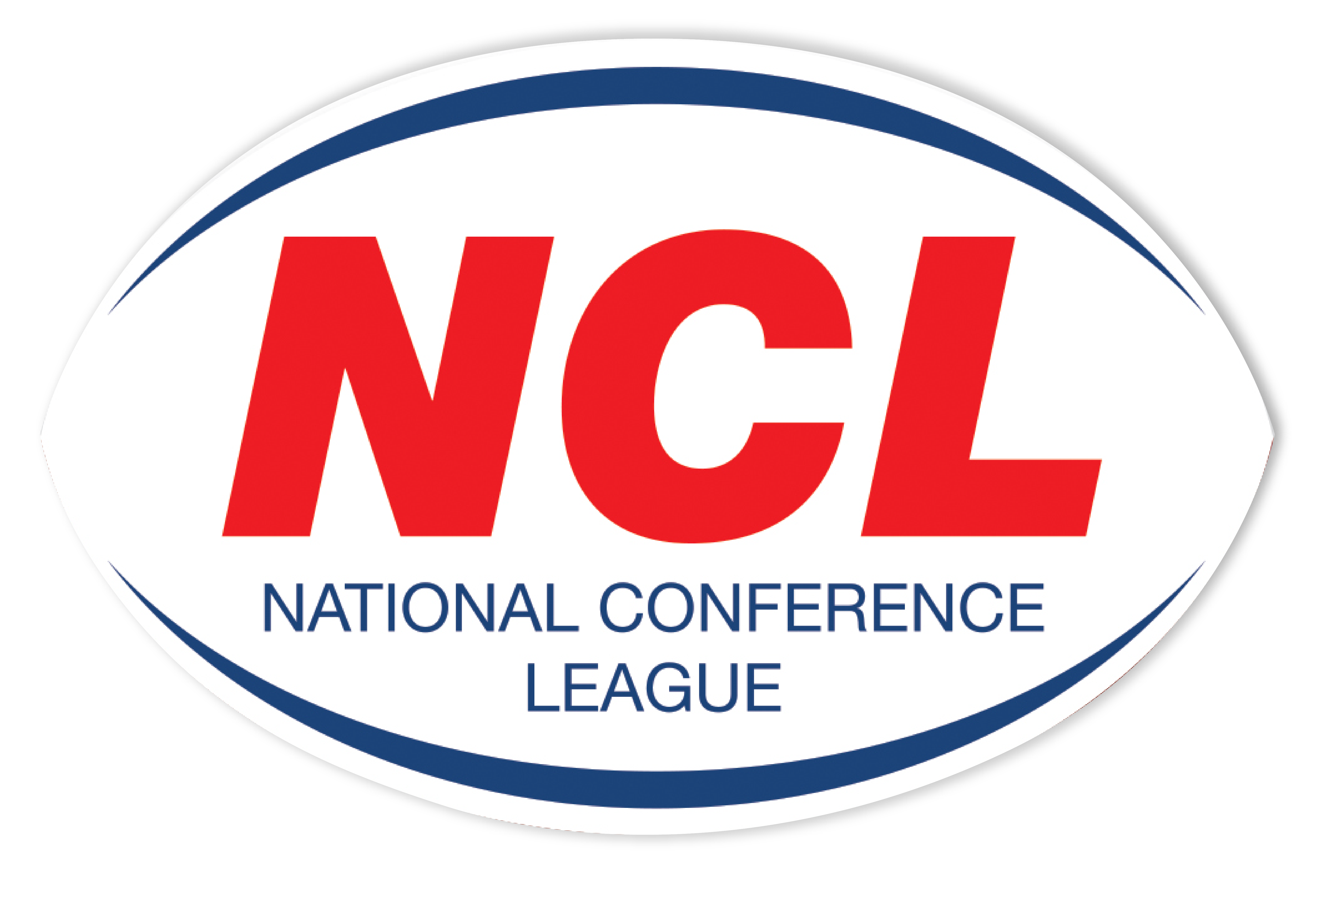NATIONAL CONFERENCE LEAGUE 2022

Minutes of the Discipline Hearing held on Wednesday 18 May 2022
 | Name | Club | Match Date | Present | Nature of Offence | Decision | Suspension Starts | Right of  Appeal
NCL 042 | Club | Hunslet Warriors | 09 04 2022 | Called In | Failing To Control Their Supporters | Guilty  £100 Fine Suspended Until 31 12 2022 | NA | NA
NCL 045 | Paul Menell | Dewsbury Moor | 23 04 2022 | Written | High Tackle  Law 15.1b | Guilty  3 Match Ban Reduced To 1 Game For Guilty Plea & Previous Good Record  £20 Fine | 21/05/2022 | Yes
NCL 046 | Lee Fewlass | Myton | 23 042022 | None | Head Butt  Law 15.1 a | Guilty  6 Match Ban Reduced To 5 Games For Previous Good Record  £100 | 21/05/2022 | No
NCL 047 | Peter Mitchell | Bradford Dudley Hill | 30 04 2022 | None | F&A To MO  Law 15.1g | Guilty  8 Match Ban Reduced To 6 Games For Guilty Plea And Previous Good Record  Fine £100 | Immediate | Yes
NCL 048 | Shane Clough (Water Carrier) | Bradford Dudley Hill | 30 04 2022 | None | - F&A To MO  - Failing To Leave The Playing Area Law 15.1g & Law 15.1i | Guilty  Playing & Touch Line Ban 31/12/2022  Fine £100 | Immediate | Yes
NCL 049 | Jack Lewis | Crosfields | 30 04 2022 | Written | Punching  Law 15.1a | Guilty  5 Match Ban Reduced To 3 Games For Guilty Plea & Previous Good Record  £60 Fine | 21/05/22 | Yes
NCL 050 | Sam Wood | Woolston | 30 04 2022 | Written | Punching  Law 15.1a | Guilty 6 Match Ban Reduced To 4 Games For Guilty Plea & Previous Good Record  £80 Fine | 21/05/2022 | Yes
NCL 051 | Club | Woolston | 30 04 2022 | Dave Whalley | Unacceptable Behaviour and or Language  Law 15.1i | Case Not Proven | NA | Yes
NCL 052 | Andy Tillett | Oulton | 30 04 2022 | None | High Tackle  Law 15.1b | Guilty  3 Match Ban Reduced To 2 Game For Guilty Plea  £40 Fine | 21/05/2022 | No
NCL 053 | Jermaine Ruan | Stanningley | 30 04 2022 | None | Use Of Elbow | TJ Report Not Submitted In Time.  No Case To Answer | NA | NA
NCL 054 | Jonty Peters | Millom | 07 05 2022 | Written | Other Contrary Behaviour  Law 15.1i | 1 Game Ban Reduced To Sending Off Sufficient For Previous Good Record | NA | Yes
NCL55 | Tyler Hart | Stanningley | 07 05 2022 | Tom Bell | Dangerous Tackle  Law 15.1b | Guilty 2 Match Ban Reduced to Sending Off Sufficient For Guilty Plea & Previous Good Record | 21/05/22 | Yes
NCL 56 | Andrew Burland | Dewsbury Moor | 07 05 2022 | Written | - Entering The Field Of Play Without Permission  - Punching Law 15.1h & Law 15.1a | Guilty  6 Match Ban Reduced To 4 Game Ban For Guilty Plea & Previous Good Record  £80 Fine | 21/05/22 | Yes
NCL 57 | Club | Bradford Dudley Hill | 07 05 2022 | None | Failing To Control Their Supporters  Law 15.1i | Guilty  £250 Fine, £125 Suspended Until 18/05/2022  £125 To Pay | NA | No
NCL 60 | Club | Hunslet Warriors | 18 05 2022 | NA | Discipline Charter  40 Points | Guilty  Fine £40 | NA | No
NCL 61 | Club | Ince Rose Bridge | 18 05 2022 | NA | Discipline Charter  40 Points | Guilty  Fine £40 | NA | No

The administration fee set aside for clubs wishing to contest the content of a match official’s report is £20, however this becomes £40 in the event of representation for two players or £60 should three players, from the same club, having been dismissed in a game wish to seek personal representation at the next discipline hearing.
All disciplinary fines imposed by the National Conference League must be remitted directly in full to the Administrator for receipt at the address below on or before
6th April 2022. The 28 day ruling given for payment applies from the original hearing date and not the date of any appeal decision.
Please Note – Notification of Suspensions/Games Served The League will not, in the run up to the 28 day expiry date window, issue reminders to clubs having failed within this period allowed to settle fines imposed. This template acts as the official notice issued by the National Conference League confirming the suspension or otherwise of players. Players against whom fines are imposed are NOT eligible for selection by their club.
Clubs must ensure that payments (Banker Cheques in favour of “NCL”) are secure as losses by post unless proven beyond all reasonable doubt cannot be classified as an excuse for non-payment by the final deadline date as issued in this communication.

Alternatively, clubs may, if they so wish and have a facility available to do so payments on-line directly to the NCL account. The NCL account number is: 29678277 Sort Code 606005 and name of account “National Conference League” When exploiting this option clubs must forward to me on the actual date of payment an email confirming that it has been made and the reason for the direct transaction. Any payment not received within 28 days from the date of imposition will mean the original fine being doubled accordingly. The NCL is not obliged to provide clubs with reminders warning them of a timescale for payment having elapsed without receipt
A Smith (NCL Administrator) Operations Dept, RFL, Cwm Ban Fawr, Llanfynydd, Carmathen, SA32 7UB.

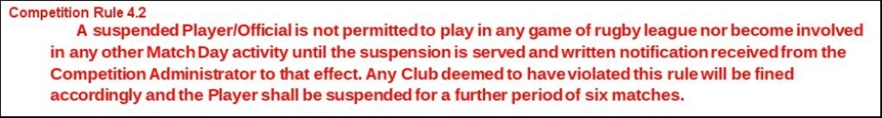

A Smith (NCL Administrator) Operations Dept, RFL, Cwm Ban Fawr, Llanfynydd, Carmathen, SA32 7UB.

